Cattle feeding management

The cattle feed ration is defined via a feed plan. For barn-fed feeds, this describes the amounts and types of feed offered to the animals. For grazed feed, it describes the amount and type of feed that is intended to be offered to the animals; the actual amount and quality available is simulated by the pasture model. In both cases, the quantity and quality of feed in the diet may differ from that offered, if the amount offered exceeds the intake capacity of the individual animals.

At least one feed plan must be made for all the types of cattle present on the farm. On farms where the animals are grazed, at least two feed plans will be defined, for winter and summer respectively. The cattle are divided into a number of feeding groups, each with its own feed plan(s). The feeding plan for the group is used for all the animals it contains. For young stock, there is one feed group per livestock category whereas for dairy and suckler cows, there are feeding groups for different ages and lactation stages. A list of the possible feeding groups is shown in Table 1.

Table 1 FASSET cattle feeding groups.

Group No. | Category | Name in file  (Alias)
0 | Heifers aged 0-0.5 years | HEIFERS1
1 | Heifers aged 0.5-1.0 years | HEIFERS2
2 | Heifers aged 1.0 years – first calving | HEIFERS3
3 | Dairy cows, first lactation, early lactation | DAIRY-1stEarly
4 | Dairy cows, first lactation, late lactation | DAIRY-1stLate
5 | Dairy cows, mature, early lactation | DAIRY-MatureEarly
6 | Dairy cows, mature, late lactation | DAIRY-MatureLate
7 | Dry dairy cows | DAIRY-Dry
8 | Cast animals (all types) | CAST
9 | Suckler cows, first lactation, early lactation | SUCKLER-1stEarly
10 | Suckler cows, first lactation, late lactation | SUCKLER-1stLate
11 | Suckler cows, mature, early lactation | SUCKLER-MatureEarly
12 | Suckler cows, mature, late lactation | SUCKLER-MatureLate
13 | Female beef calves, age 0-0.5 years | FBEEF1
14 | Female beef calves, age 0.5-1.0 years | FBEEF2
15 | Female beef calves, age 1.0 years to calving | FBEEF3
16 | Male beef calves, age 0-0.5 years | MBEEF1
17 | Male beef calves, age 0.5-1.0 years | MBEEF2
18 | Male beef calves, age 1.0 years to slaughter | MBEEF3

If the animals are grazed, an additional feed control mechanism may be used to enable the cattle to maintain production, in the face of variations in the supply of grazed forage caused by variations in the growing conditions experienced by the pasture.

A diet must be defined for all groups. For groups containing non-lactating animals (numbers 0 to 2 inclusive, numbers 7 and 8, and numbers 13 to 18 inclusive), a single diet must be defined. Within group numbers 3 to 6, 9 to 12 inclusive, the feed rations may be defined according to the status of the herbage available for grazing; deficient, normal or in surplus. The boundaries between deficiency, normal or surplus are defined in terms of the number of days worth of grazing that are currently present. The boundaries for deficiency to normal and for normal to surplus are defined using the variables lowerGrazingLimit and upperGrazingLimit respectively and are read from the file opsman.dat.

The diet can be specified using two methods. In the first method, the amounts of the different feed items are specified explicitly, either in kg DM or in Scandinavian Feed Units. In the second method, the proportion of energy to be obtained from roughage feed and the proportion that roughage that should come from grazing are specified but the amounts of these feeds, and the amount of concentrate feed, are calculated by the model. Only one method can be used at any one time and is valid for all feeding groups.

Method 1

The quantity and quality of grazed feed assumed to be on offer is defined. The number of barn-fed feed items that can be specified in the diet is variable (although at least one of the defined), with each feed item identified by a feed code. The codes, names and characteristics of the feed items are stored in the file? In addition to defining the feeds on offer, feed plan also specifies the number of hours per day that the animals in the feeding group are in the animal housing.

The feeding plans are input via the file cattleFeedPlan.dat. Figure 1 shows a schematic of the rationing system.

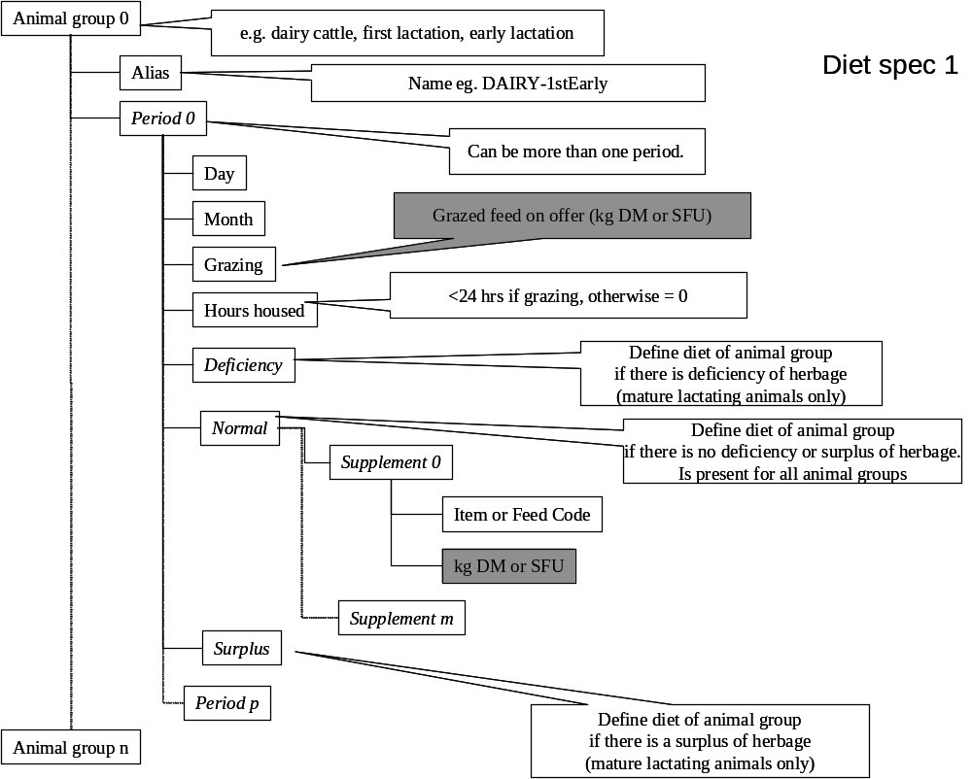
Figure 1 Schematic of feed ration system, Method 1

Method 2

As before, the feeding plans are input via the file cattleFeedPlan.dat. The ration is defined in the following terms:
- The proportion of energy that is consumed as roughage.
- The proportion of the roughage that is consumed as grazed feed with a specified feed code.
- The feed code of any supplementary concentrate feed.
- The feed code of any supplementary roughage feed.

The model then calculates the amounts of these feeds that are necessary to fulfil the energy and protein demand of the animals.

Figure 2 shows a schematic for defining a feed plan using Method 2.

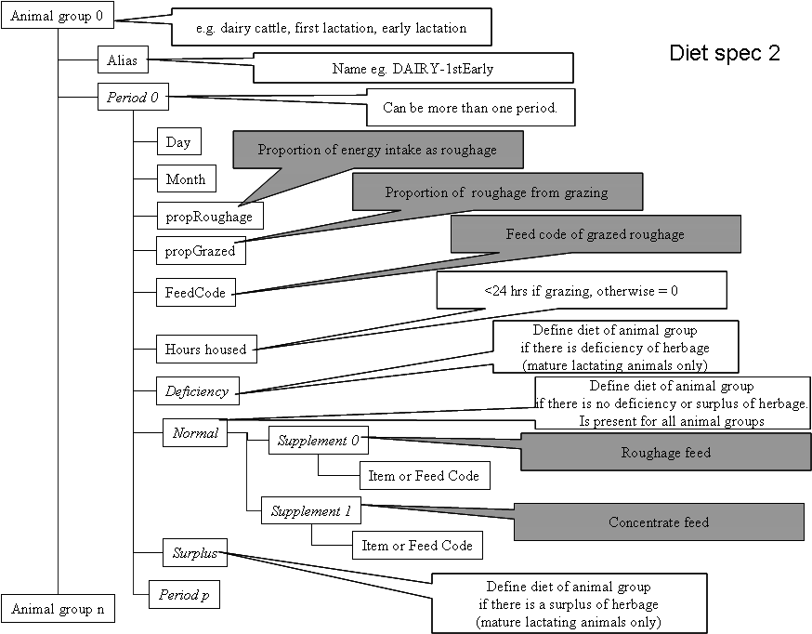
Figure 1 Schematic of feed ration system, Method 1

Technical specification

The cattle feeding management is controlled by the cattlefeeding_manager_class (cattlefeeding_manager_class.cpp), an instance of which is a member of the Operations_manager_class (Operations_manager_class.cpp). The main functions of the cattlefeeding_manager_class are AutoFeed and SortAnimals functions. AutoFeed is called once per year and calculates the energy and protein demand of all the animal groups. It then generates the feeding plans for the animals. The SortAnimals function is called on a daily basis and allocates individual animals to their appropriate feeding group.

